Abstract
Deaf-blind individuals face significant challenges in independent mobility and environmental awareness due to the combined loss of hearing and vision. This project proposes a Smart Assistive Navigation Band designed to enhance safety, communication, and independent travel for deaf-blind users through tactile feedback technology.
The proposed wearable band integrates a sound detection sensor, GPS module, vibration motor array, and electromechanical Braille-based directional buttons. When environmental sounds such as vehicle horns, alarms, or human voices are detected, the system converts them into distinct vibration patterns to alert the user. For navigation, the user can input a destination, and the integrated GPS system provides real-time directional guidance. Instead of audio or visual cues, the band communicates directions using four dynamically rising Braille-based buttons (representing forward, backward, left, and right). The user can physically feel the raised indicators to understand the navigation direction. Additionally, vibration alerts are provided when a turn is required.
An emergency assistance feature is incorporated into the band. When activated, it automatically sends an alert and initiates a call to a predefined caretaker contact, ensuring immediate support during critical situations.
This system aims to improve independent mobility, situational awareness, and personal safety for deaf-blind individuals using affordable and wearable assistive technology. The proposed solution promotes inclusivity, accessibility, and empowerment, contributing toward enhanced quality of life for persons with dual sensory impairments. analyze this abstract i will you give the questions
BLOCK DIAGRAM
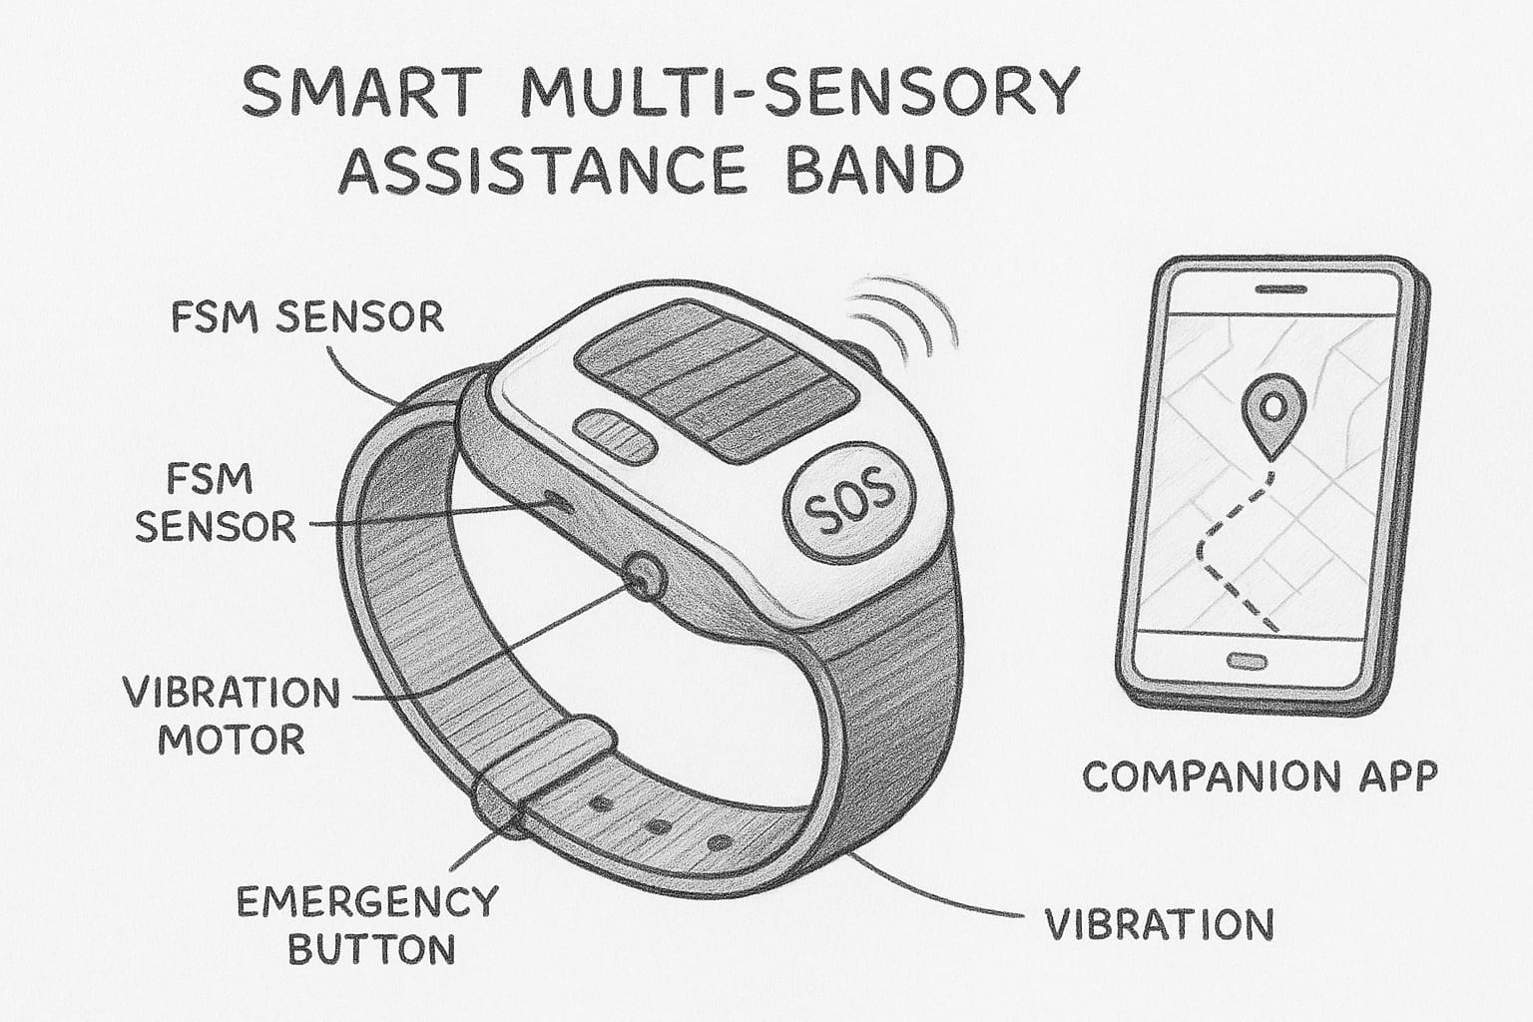
Product basic type
